TUTORIAL 8B
FASTER RCNN on Pre-Trained Model
Tasks:
- Test it with your own image
- Take another two models with different backbones
In this task, a pretrained Faster R-CNN model was used to perform object detection on a sample image of a Lamborghini and a custom labeled gun dataset. The performance of the model was evaluated using Intersection over Union (IoU), Precision, Recall, and mean Average Precision (mAP).
Additionally, different backbone architectures were tested to analyze their effect on detection accuracy and speed..
Procedure
- The pretrained Faster R-CNN model (fasterrcnn_resnet50_fpn) was loaded for object detection.
- A sample Lamborghini image was passed through the model to evaluate baseline detection performance.
- Multiple backbone architectures were tested, including:
- ResNet50
- ResNet50 V2
- MobileNetV3
- The models were compared based on number of detections and inference time.
- A custom labeled gun dataset (5 test images) was imported and evaluated using the trained model.
- Predictions were generated including:
- Bounding boxes
- Confidence scores
- Class labels
- A confidence threshold was applied to filter weak detections.
- Ground truth annotations were used for evaluation.
- IoU was calculated between predicted and ground truth bounding boxes.
- Precision, Recall, Average Precision (AP), and mean Average Precision (mAP) were computed using COCO evaluation metrics.
Results and Analysis
- ResNet50 Backbone
- ResNet50 backbone detected 2 objects in 5.38 seconds, showing balanced performance between speed and accuracy.
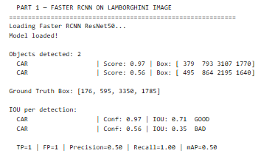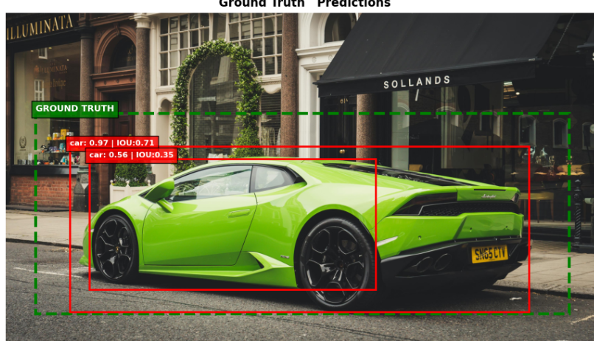
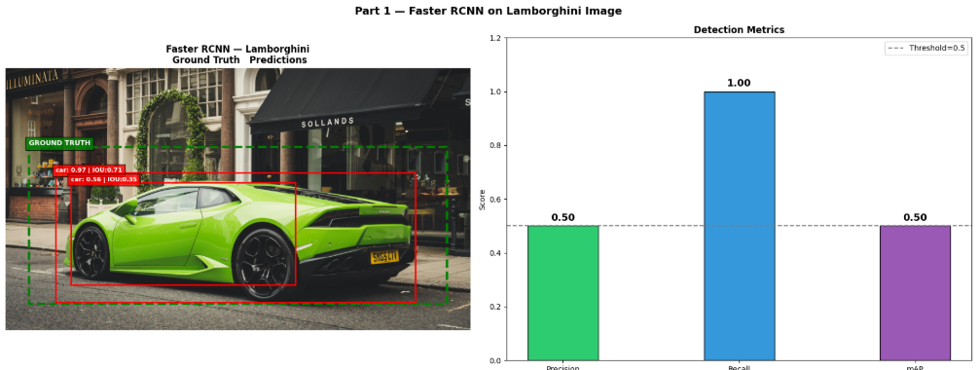
- ResNet50 V2 Backbone
- ResNet50 V2 backbone detected 9 objects in 9.55 seconds, producing the highest number of detections but requiring more computation time.
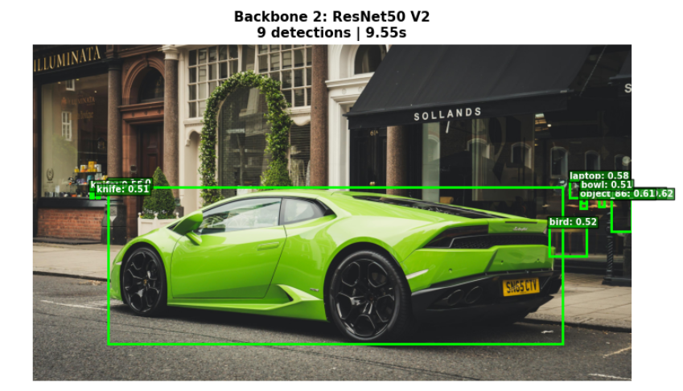

- MobileNetV3 Backbone
- MobileNetV3 backbone detected only 1 object in 1.07 seconds, making it the fastest model but with the lowest detection performance.
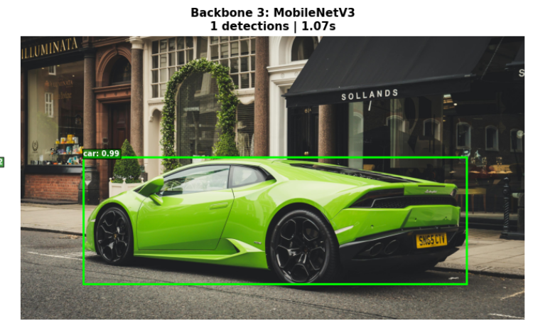
These results clearly show that changing the backbone directly affects both the number of detected objects and inference time.
- More detections (ResNet50 V2)
- Balanced performance (ResNet50)
- Faster but weaker detection (MobileNetV3)
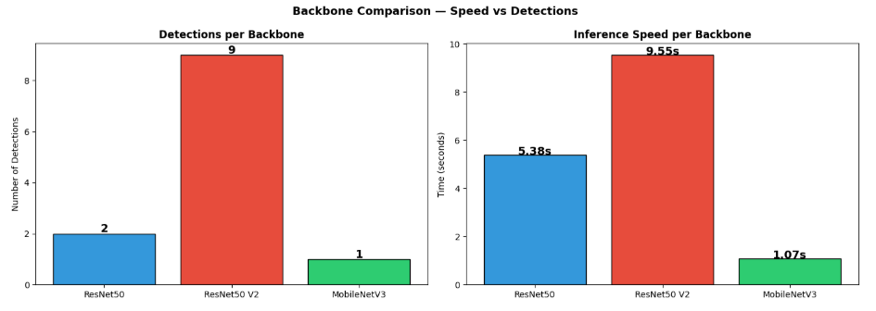
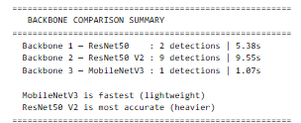
Task 3
Take a bunch of data for evaluating and then find its mAP
Then the pretrained Faster R-CNN model was evaluated on 5 labeled gun images using ResNet50 backbone. For each image, Ground Truth (GT) boxes, predicted boxes, and Average Precision (AP) were recorded to measure detection performance.
The results are summarized below:
- Image 1: GT = 5, Predictions = 1, AP = 0.453
- Image 2: GT = 1, Predictions = 6, AP = 0.091
- Image 3: GT = 1, Predictions = 2, AP = 0.040
- Image 4: GT = 1, Predictions = 1, AP = 0.000
- Image 5: GT = 1, Predictions = 2, AP = 0.000
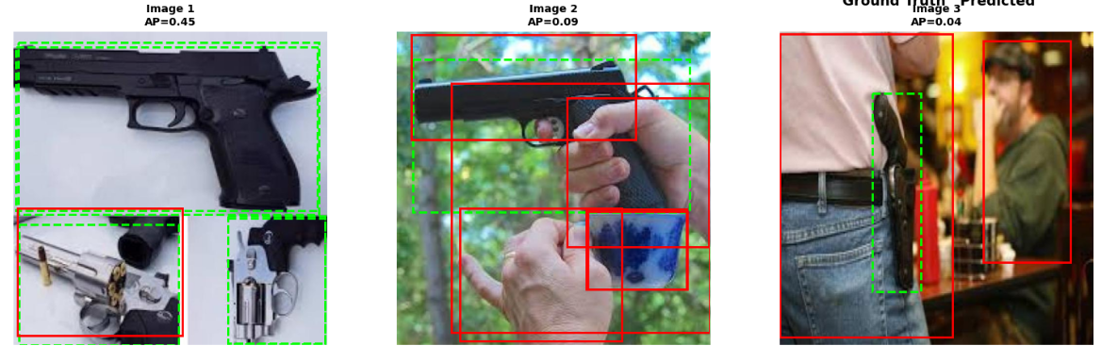
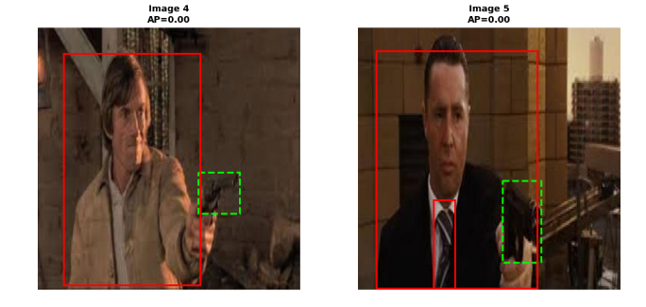
Result and Analysis
The results show inconsistent performance of the model across different images. In some cases, such as Image 1, the model was able to detect objects with relatively better accuracy (AP = 0.453), although it still missed several ground truth objects. In other images, the model produced multiple incorrect predictions or failed to align bounding boxes properly with the ground truth, resulting in very low AP values.
It was also observed that in some cases, even when predictions were present, the AP value was zero. This occurred due to poor overlap (low IoU) between predicted and ground truth bounding boxes, indicating incorrect localization.
mAP Evaluation
The overall performance of the model was measured using mean Average Precision (mAP) across all test images.
- Final mAP@0.50 = 11.7%
This low mAP value indicates that the model struggles to generalize well on the custom gun dataset. The poor performance is mainly due to limited dataset size, domain difference, and inconsistent detections across images.

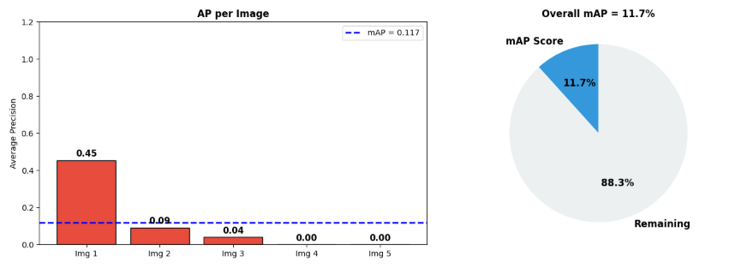
Conclusion
The Faster R-CNN model shows weak and inconsistent performance on the custom dataset, achieving only 11.7% mAP. While it can detect objects in some cases, overall accuracy is low due to false positives, missed detections, and poor bounding box alignment. This confirms that the pretrained model requires fine-tuning on domain-specific data to achieve better results.
